-- Embargo Monday, 22.06.2020, 6:00 AM CET --

Archaeologists discover a massive circle of prehistoric shafts near Stonehenge

Stonehenge may be one of the best-known archaeological sites on earth, but a team of archaeologists are celebrating the discovery of a major new prehistoric monument only a short distance away from Stonehenge. Recent fieldwork and analysis have revealed evidence for 20 or more massive, prehistoric shafts, measuring more than 10 metres in diameter and 5 metres deep. These shafts form a circle more than 2 kilometres in diameter and enclose an area greater than 3 square kilometres around the Durrington Walls henge, one of Britain’s largest henge monuments, and the famous, smaller prehistoric circle at Woodhenge.

Coring of the shafts provided radiocarbon dates indicating that these features are Neolithic and were excavated more than 4,500 years ago, around the time that Durrington Walls was constructed. Archaeologists believe that the shafts served as a boundary to a sacred area or precinct associated with the henge. The Neolithic period, which is associated with the first farmers in Britain, is characterised by the development of ornate, and occasionally very large, rituals structures and enclosures, including the great stone circle at Stonehenge. However, no comparative prehistoric structure in the UK encloses such a large area as the circle of shafts at Durrington, and the structure is currently unique.

Aside from the scale of the structure, the circuit of shafts has other surprising characteristics. The boundary appears to have been deliberately laid out to include an earlier prehistoric monument within the boundary - the Larkhill Causewayed Enclosure. This site was built more than 1,500 years before the henge at Durrington. This distance between the henge and earlier enclosure, more than 800 metres, seems to guide the placement of shafts around Durrington. The evidence for how these features were laid out is extremely important as implies that the early inhabitants of Britain used a tally or counting system to track pacing across long distances. Evidence for such careful planning, at such a scale, is unexpected and emphasises how important the positioning of these features was.

Archaeologists believe the effort invested in the circuit inscribed by the pits reflects an important cosmological link between these two ritual sites, and that the large shafts were dug to record what must have been an important, sacred boundary. The presence of such massive features, and perhaps an internal post line, guided people towards the religious sites within the circle or may have warned those who were not permitted to cross the boundary marked by the shafts.

Research on the pits at Durrington was led by the University of Bradford and undertaken by a consortium of archaeologists as part of the Stonehenge Hidden Landscapes Project. Partners include the Ludwig Boltzmann Institute for Archaeological Prospection and Virtual Archaeology in cooperation with the Universities of Birmingham, St Andrews, Warwick, University of Wales Trinity Saint David, and the Scottish Universities Environmental Research Centre (University of Glasgow). Work at Durrington was facilitated by the National Trust and supported by the University of Bradford Research Development Fund

Full publication of research at Durrington has been published as an open access article by Internet Archaeology at - https://doi.org/10.11141/ia.55.4

Professor Vincent Gaffney (University of Bradford) said “The size of the shafts and circuit surrounding Durrington Walls is without precedent within the UK. It demonstrates the significance of Durrington Walls Henge, the complexity of the monumental structures within the Stonehenge landscape, and the capacity and desire of Neolithic communities to record their cosmological belief systems in ways, and at a scale, that we had never previously anticipated.

Professor Wolfgang Neubauer (LBI ArchPro, University of Vienna) said “It is amazing that our seamless survey of the Stonehenge landscape, which applies the latest technology and extends over kilometres of countryside, has revealed major new features including these huge shafts. They are not only clearly visible in the geophysical data sets, the survey also provides the opportunity to place these features within a wider context comprising the many monuments associated with Stonehenge including the super-henge at Durrington Walls, three kilometres north-east from the iconic stone circle.”

Dr Chris Gaffney (University of Bradford) said “The “Stonehenge Hidden Landscapes” datasets offer unparalleled interpretations of the 'empty spaces' between the fabulous monuments that make up the World Heritage Site. Seemingly isolated features have been shown to be linked and significant to the story of the emergence of the ritual landscape. An interdisciplinary approach, using a battery of techniques, has been key to the successful understanding of this complex but structured element of the landscape around Durrington Walls. “

Dr Richard Bates (University of St Andrews) said “Seeing what is unseen! Yet again, the use of a multidisciplinary effort with remote sensing and careful sampling is giving us an insight to the past that shows an even more complex society that we could ever imagine. Clearly sophisticated practices demonstrate that the people were so in tune with natural events to an extent that we can barely conceive in the modern world we live in today.”

Tim Kinnaird (University of St Andrews) said “The sedimentary infills contain a rich and fascinating archive of previously unknown environmental information, and with optically stimulated luminescence profiling and dating, we can write detailed narratives of the Stonehenge landscape for the last 4,000 years.”

Dr Martin Bates (University of Wales, Trinity Saint David, Lampeter) said “When discovering features of this size in the past, antiquarians and earlier archaeologists would have applied relatively coarse methodologies, primarily excavation, to discover more. Today, we can be more cautious and sympathetic to the archaeology. Precision coring, guided by remote sensing, and a bit of luck, has allowed us to recover bone fragments close to the base of one of these features and that has allowed us to date their initial infilling”.

Eamonn Baldwin (University of Birmingham) said “The Stonehenge landscape stands apart, not only as one of the most important archaeological landscapes in the world, but also amongst the best studied. To make such a major discovery within such an area is remarkable, and testament to how archaeologists have begun to integrate technology with traditional research methods including excavation and aerial photographic survey.”

Professor Henry Chapman (University of Birmingham) said "After centuries of study of the Stonehenge landscape, the discovery of such an incredible new monument is testament to the value of interdisciplinary research. Our understanding of this outstanding place has been transformed in recent years, and the identification of such a significant and extensive new site highlights that there is always something more to discover."

Professor Robin Allaby (University of Warwick) said “We’re tremendously excited at the prospect of applying ancient sedimentary DNA technology to these mysterious structures to discover their purpose in ancient Britain”

Dr Nick Snashall, National Trust archaeologist for the Stonehenge and Avebury World Heritage Site, said: “As the place where the builders of Stonehenge lived and feasted Durrington Walls is key to unlocking the story of the wider Stonehenge landscape, and this astonishing discovery offers us new insights into the lives and beliefs of our Neolithic ancestors.

“The Hidden Landscapes team have combined cutting-edge, archaeological fieldwork with good old-fashioned detective work to reveal this extraordinary discovery and write a whole new chapter in the story of the Stonehenge landscape.”

For more information, contact:

University of Bradford
Press Office
Neil Hudson n.hudson2@bradford.ac.uk
Academic Contacts
Prof. Vincent Gaffney v.gaffney@bradford.ac.uk
Dr Chris Gaffney C.Gaffney@bradford.ac.uk
School of Archaeological and Forensic Sciences, University of Bradford

Ludwig Boltzmann Institute for Archaeological Prospection & Virtual Archaeology
Academic and Press Contact
Professor Wolfgang Neubauer Wolfgang.Neubauer@archpro.lbg.ac.at
+43 664 8174991

The National Trust
Press Office
Sue Wharmby Sue.Wharmby@nationaltrust.org.uk
Academic Contacts
Dr Nic Snashall, Nicola.Snashall@nationaltrust.org.uk

The University of Birmingham
Press Office
Hasan Patel (Communications) H.S.Patel@bham.ac.uk
Academic Contacts
Mr Eamonn Baldwine.p.baldwin@bham.ac.uk
Dr Henry Chapman h.chapman@bham.ac.uk
Dr Paul Garwood p.j.garwood@bham.ac.uk

The University of St Andrews
Press Office
Press Office proffice@st-andrews.ac.uk.
Academic Contacts
Dr Richard Bates crb@st-andrews.ac.uk
Dr Tim Kinnaird tk17@st-andrews.ac.uk

University of Wales, Trinity St Davids, Lampeter
Press Office
Arwel Lloyd Arwel.Lloyd@uwtsd.ac.uk
Academic Contacts
Dr Martin Bates m.bates@uwtsd.ac.uk

University of Warwick
Press Office
Scott, Alice Alice.J.Scott@warwick.ac.uk
Frew, Tom A.T.Frew@warwick.ac.uk
Academic Contacts
Professor Robin Allaby R.G.Allaby@warwick.ac.uk

The Scottish Universities Environmental Research Centre (University of Glasgow)
Press Office
media@glasgow.ac.uk
Academic Contacts
Dr Derek Hamilton derek.hamilton.2@glasgow.ac.uk

Notes
The universities undertaking field research supporting this press release included the University of Bradford with the Ludwig Boltzmann Institute for Archaeological Prospection and Virtual Archaeology the Universities of Birmingham, St Andrews, Trinity Saint David (University of Wales), Warwick, and the Scottish Universities Environmental Research Centre. The work was undertaken a part of the Stonehenge Hidden Landscapes Project and brought together experts in non-invasive geophysical prospection and remote sensing, and specialists in British prehistory and landscape archaeology in order to carry out research in one of the most important archaeological landscapes in Europe. The outstanding geophysical survey and visualization capabilities of the team has been made possible only because of the unique expertise and combined resources of the wider project partnership. An international collaboration of the Ludwig Boltzmann Gesellschaft (Austria), Amt der Niederösterreichischen Landesregierung (Austria), the University of Vienna (Austria), the Vienna University of Technology (Austria), ZAMG– the Central Institute for Meteorology and Geodynamics (Austria), Airborne Technologies (Austria), 7reasons (Austria), ÖAW– Austrian Academy of Sciences (Austria), ÖAI – Austrian Archaeological Institute (Austria), RGZM Mainz – Römisch‐Germanisches Zentralmuseum Mainz (Germany), the University of Birmingham in collaboration with the University of Bradford (GB), Arkeologerna of Statens Historiska Museer (Sweden), NIKU – Norwegian Institute for Cultural Heritage (Norway), and Vestfold fylkeskommune – Kulturarv (Norway).

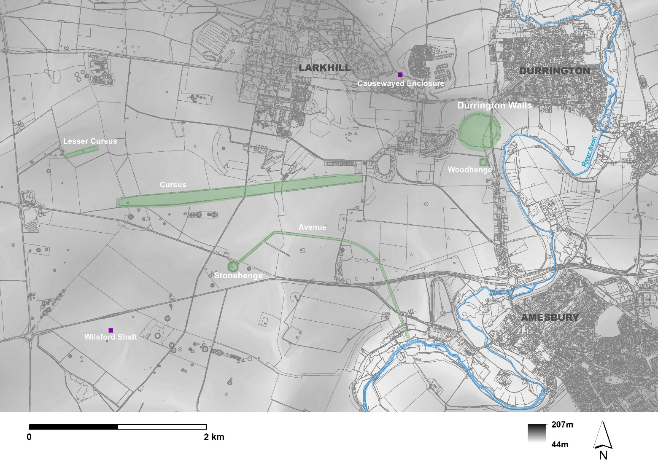

The Stonehenge landscape and principal monuments.
© Crown copyright and database rights 2019 (OS MasterMap® Scale 1:1250) and 2013 (OS Profile DTM Scale 1:10000); EDINA Digimap Ordnance Survey Service (100025252) http://digimap.edina.ac.uk

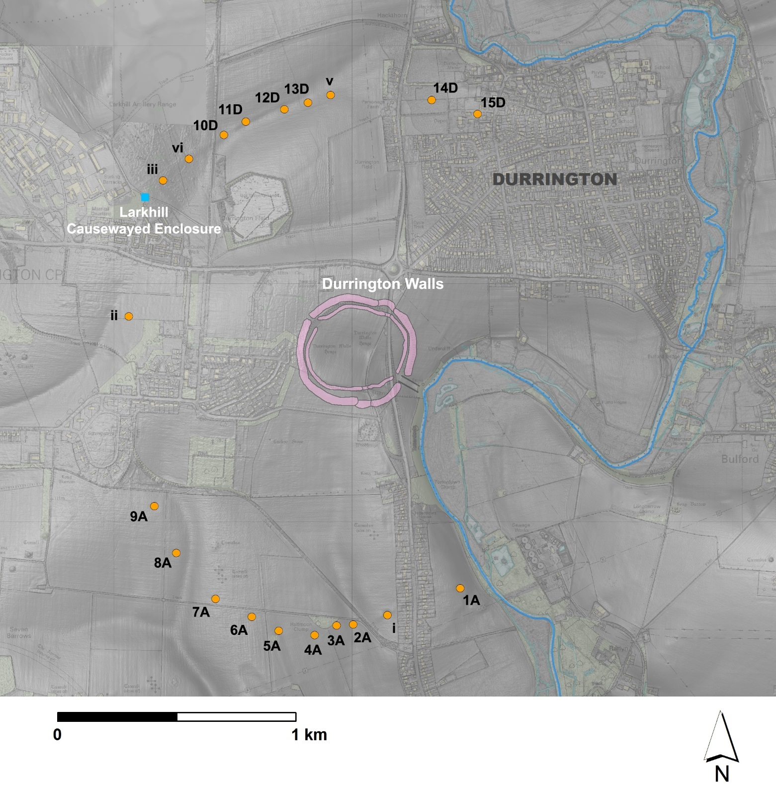
Map showing the position of known and probable pits around Durrington Walls henge
© Crown copyright and database rights 2019 (OS MasterMap® Scale 1:1250) and 2013 (OS Profile DTM Scale 1:10000); EDINA Digimap Ordnance Survey Service (100025252) http://digimap.edina.ac.uk

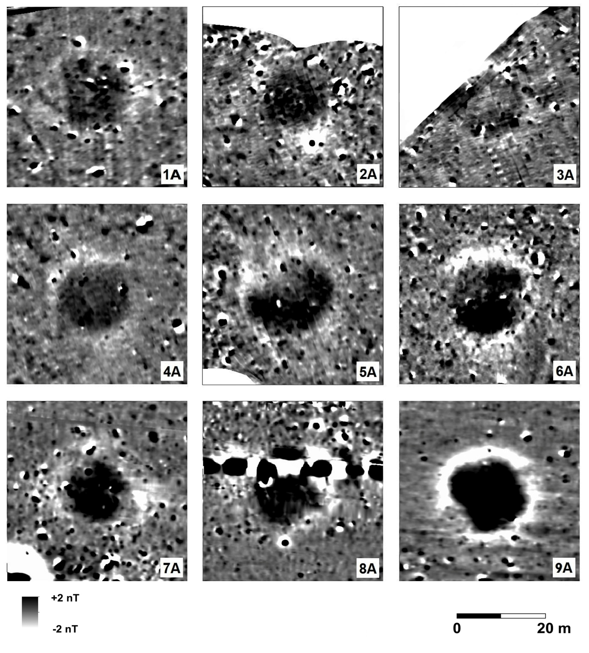
Magnetic anomalies 1A to 9A3. Fluxgate Gradiometer survey data mapped as part of the SHLP and supplied by LBI ArchPro.

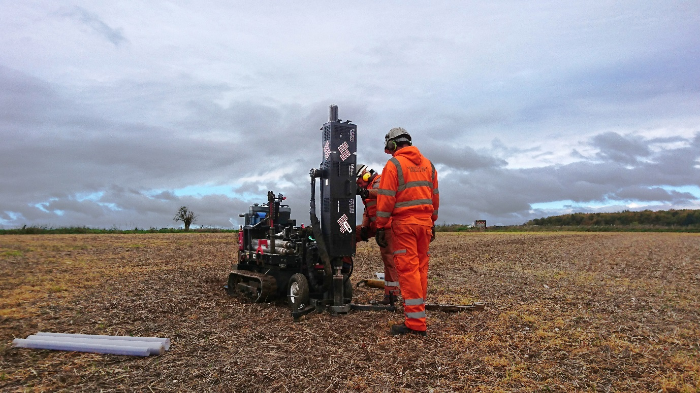

Coring in action at 7A looking northwest to anomalies 6A –7A, Strangways and Larkhill

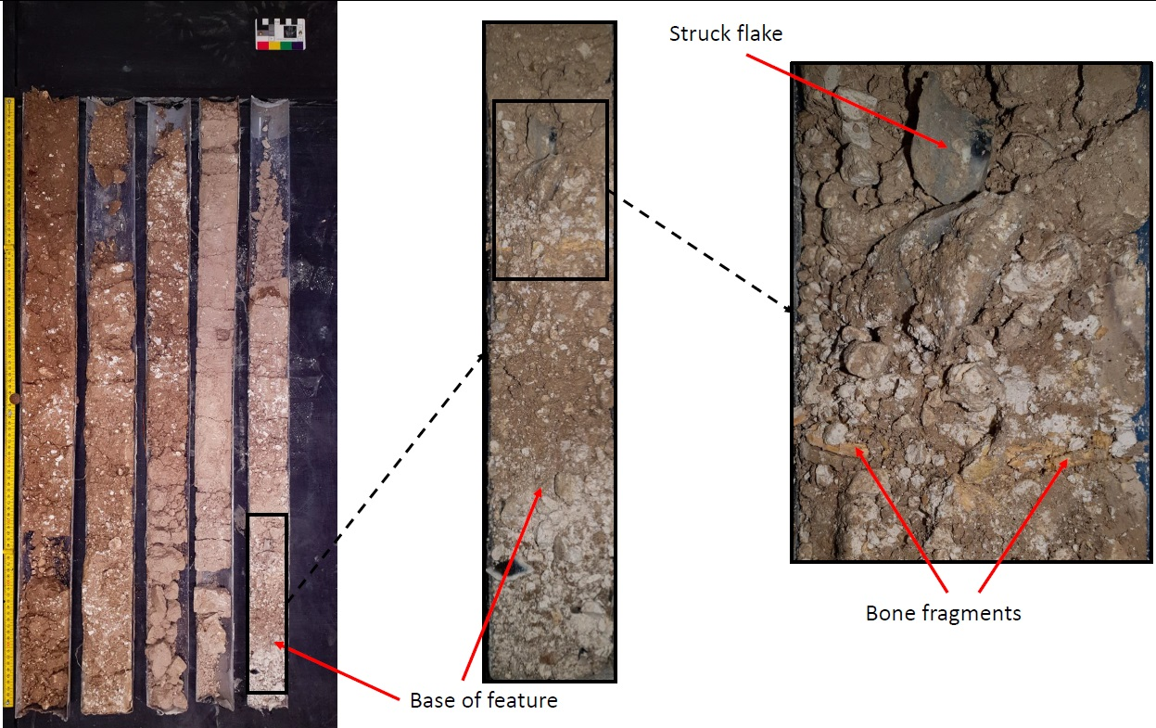
Feature 8A core profile in metre lengths showing struck flint and bone fragments in lower fills

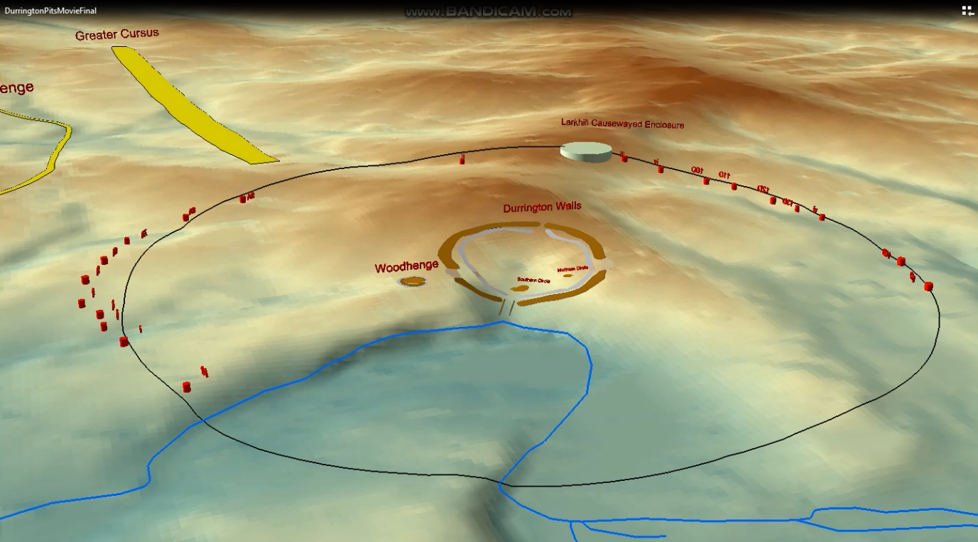
Animation illustrating the landscape setting of the Durrington pit group, major monuments and the average distance from Durrington Walls to identified features as a line.
© Crown copyright and database rights 2013 (OS Profile DTM Scale 1:10000); EDINA Digimap Ordnance Survey Service (100025252) http://digimap.edina.ac.uk

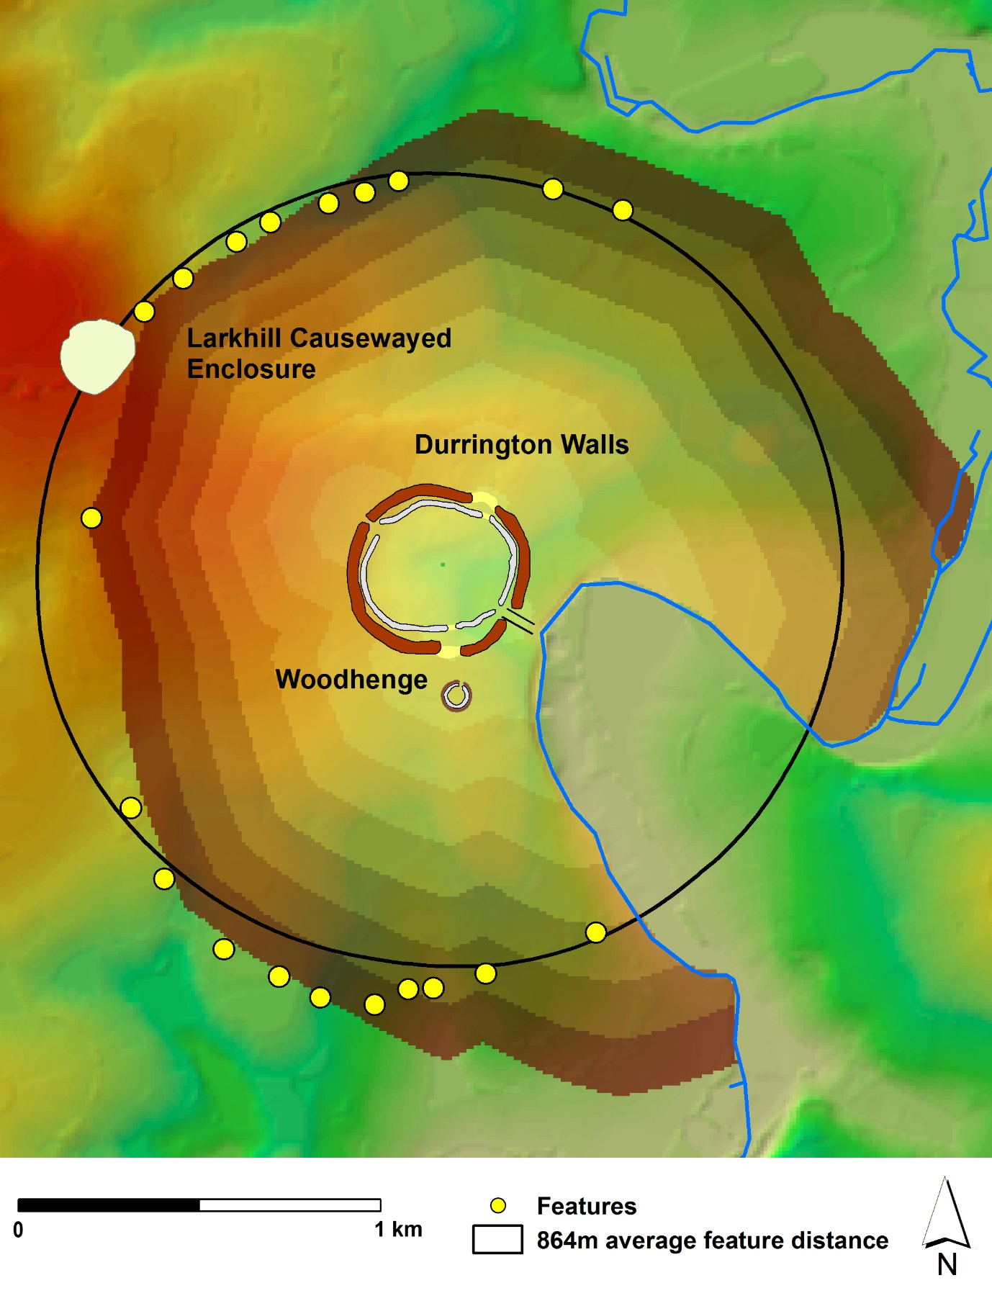
Average pit distance to shafts as a circular boundary and a simple energy cost map representing effort to walk from Durrington Walls and cropped at the Larkhill Causewayed enclosure.
© Crown copyright and database rights 2013 (OS Profile DTM Scale 1:10000); EDINA Digimap Ordnance Survey Service (100025252) http://digimap.edina.ac.uk

